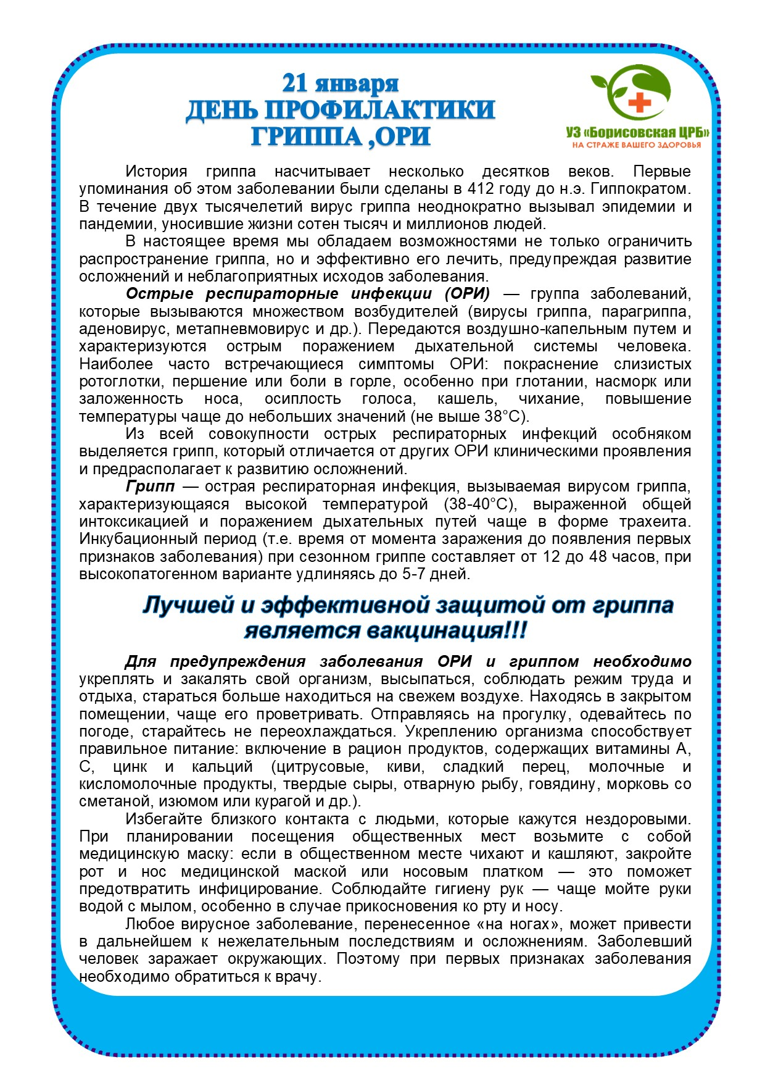

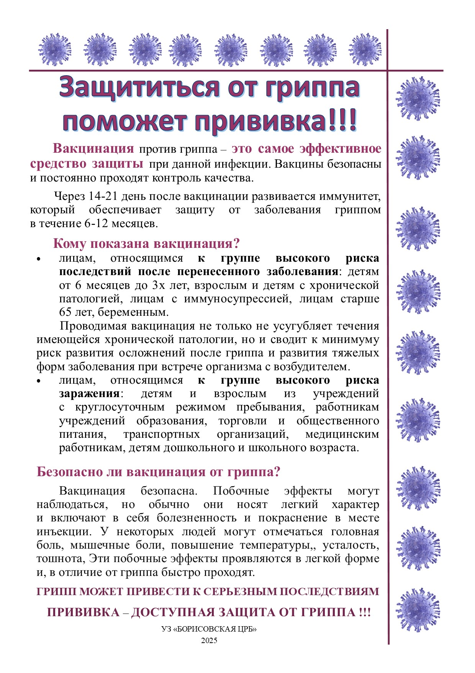

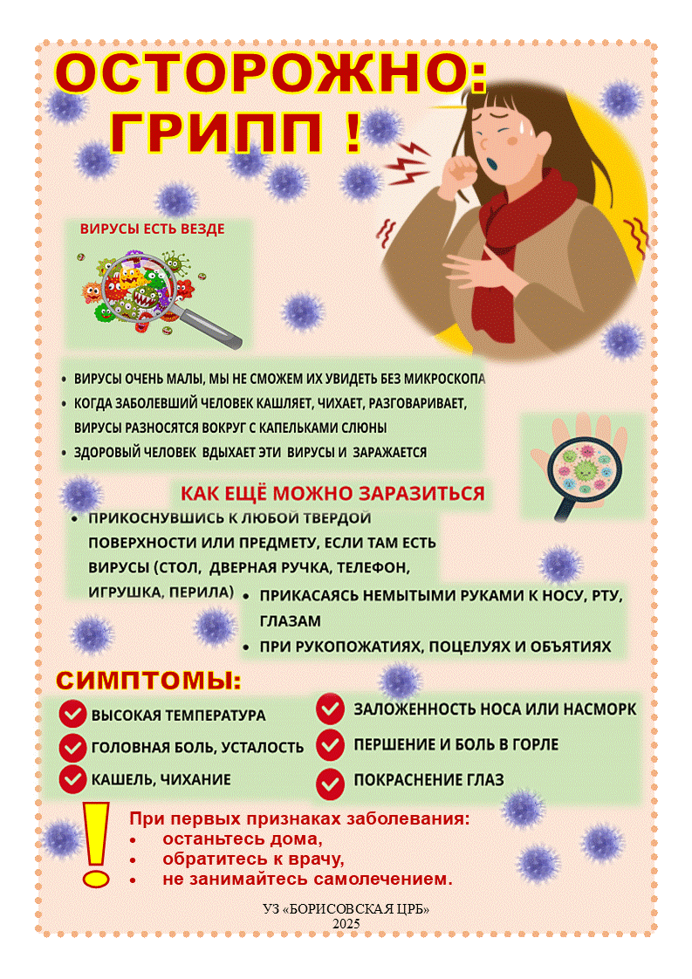

Полезные ссылки:

<https://www.who.int/home/search-results?indexCatalogue=genericsearchindex1&searchQuery=%D0%B3%D1%80%D0%B8%D0%BF%D0%BF&wordsMode=AnyWord>

<https://minzdrav.gov.by/ru/search/index.php?q=%D0%B3%D1%80%D0%B8%D0%BF%D0%BF>

<https://www.youtube.com/watch?v=Kk1My6JjyHM>

<https://yandex.by/video/preview/14562134584171377681?rdrnd=894352>

<https://drive.google.com/file/d/1Mjy1gTyG24tnbKWy970103GnKRpuys-l/view>

<https://drive.google.com/file/d/1fyXukqptQy9Mv1UQEsO1F48WwEEuwoEy/view>  
<https://drive.google.com/file/d/15CXNDF1YTxZ3afbqOfLlWQYSzxIAJ5qN/view?usp=drive_link>